Solution is on PAGE 5
Inventory Management System for B2B SaaS
Overview
You're joining a team building "StockFlow" - a B2B inventory management platform. Small businesses use it to track products across multiple warehouses and manage supplier relationships.
Time Allocation
Take-Home Portion: 90 minutes maximum
Live Discussion: 30-45 minutes (scheduled separately)

Part 1: Code Review & Debugging (30 minutes)
A previous intern wrote this API endpoint for adding new products. Something is wrong - the code compiles but doesn't work as expected in production.
@app.route('/api/products', methods=['POST'])
def create_product():
data = request.json

# Create new product
product = Product(
name=data['name'],
sku=data['sku'],
price=data['price'],
warehouse_id=data['warehouse_id']
)

db.session.add(product)
db.session.commit()

# Update inventory count
inventory = Inventory(
product_id=product.id,
warehouse_id=data['warehouse_id'],
quantity=data['initial_quantity']
)

db.session.add(inventory)
db.session.commit()

return {"message": "Product created", "product_id": product.id}

Your Tasks:
- Identify Issues: List all problems you see with this code (technical and business logic)
- Explain Impact: For each issue, explain what could go wrong in production
- Provide Fixes: Write the corrected version with explanations
Additional Context (you may need to ask for more):
Products can exist in multiple warehouses
SKUs must be unique across the platform
Price can be decimal values
Some fields might be optional

Part 2: Database Design (25 minutes)
Based on the requirements below, design a database schema. Note: These requirements are intentionally incomplete - you should identify what's missing.
Given Requirements:
Companies can have multiple warehouses
Products can be stored in multiple warehouses with different quantities
Track when inventory levels change
Suppliers provide products to companies
Some products might be "bundles" containing other products
Your Tasks:
Design Schema: Create tables with columns, data types, and relationships
Identify Gaps: List questions you'd ask the product team about missing requirements
Explain Decisions: Justify your design choices (indexes, constraints, etc.)
Format: Use any notation (SQL DDL, ERD, text description, etc.)

Part 3: API Implementation (35 minutes)
Implement an endpoint that returns low-stock alerts for a company.
Business Rules (discovered through previous questions):
Low stock threshold varies by product type
Only alert for products with recent sales activity
Must handle multiple warehouses per company
Include supplier information for reordering
Endpoint Specification:
GET /api/companies/{company_id}/alerts/low-stock

Expected Response Format:
{
"alerts": [
{
"product_id": 123,
"product_name": "Widget A",
"sku": "WID-001",
"warehouse_id": 456,
"warehouse_name": "Main Warehouse",
"current_stock": 5,
"threshold": 20,
"days_until_stockout": 12,
"supplier": {
"id": 789,
"name": "Supplier Corp",
"contact_email": "orders@supplier.com"
}
}
],
"total_alerts": 1
}

Your Tasks:
- Write Implementation: Use any language/framework (Python/Flask, Node.js/Express, etc.)
- Handle Edge Cases: Consider what could go wrong
- Explain Approach: Add comments explaining your logic
Hints: You'll need to make assumptions about the database schema and business logic. Document these assumptions.

Submission Instructions
Create a document with your responses to all three parts
Include reasoning for each decision you made
List assumptions you had to make due to incomplete requirements
Submit within 90 minutes of receiving this case study
Be prepared to walk through your solutions in the live session

Live Session Topics (Preview)
During our video call, we'll discuss:
Your debugging approach and thought process
Database design trade-offs and scalability considerations
How you'd handle edge cases in your API implementation
Questions about missing requirements and how you'd gather more info
Alternative approaches you considered

Evaluation Criteria
Technical Skills:
Code quality and best practices
Database design principles
Understanding of API design
Problem-solving approach
Communication:
Ability to identify and ask about ambiguities
Clear explanation of technical decisions
Professional collaboration style
Business Understanding:
Recognition of real-world constraints
Consideration of user experience
Scalability and maintenance thinking

Note: This is designed to assess your current skill level and learning potential. We don't expect perfect solutions - we're more interested in your thought process and ability to work with incomplete information.

Document Title: Bynry Case Study Submission - StockFlow
Candidate: Nishant Sharma
Date: 09 April 2026

Part 1: Code Review & Debugging

Issue - 1 -> No duplicate check for same product/sku, if there are same product/sku found, then db will crash or give error at the last level, this ignores Fail Fast approach.
My solution -> add duplicate check, if found throw error ‘duplicate product/sku’ with respective error code
Code ->
const existingProduct = await prisma.product.findUnique({ where: { sku: sku } });
if (existingProduct) {
// Return 409 Conflict immediately
return res
.status(409)
.json({ error: `A product with SKU '${sku}' already exists.` }); }

Issue - 2 -> DOUBLE Transactions with NO ROLLBACK, if there is failure in the transaction at any point of time the query fails if there is either orphaned data in db or a data mismatch.
My solution -> combine both creating and updating the inventory in a single transaction, so if there is failure at any point of time, whole transaction is rolled back to original state
Code -> // use Prisma's interactive transaction
const result = await prisma.$transaction(
async (tx) => {
// create the product
const newProduct = await tx.product.create({
data: { name, sku, price: parseFloat(price), warehouseId: warehouse_id } });
// create the Inventory record
const newInventory = await tx.inventory.create({
data: { productId: newProduct.id, warehouseId: warehouse_id, quantity: parseInt(initial_quantity) } });

Issue - 3 -> No data validation, So basically we are getting data from json in the request, but the data is not validated, what if the price contains char or some fields are empty.
My solution -> add proper validation, this could be done via a validator middleware which intercepts the requests check if it is valid, if not, throws error even before the request reaches the controller
Code ->// using zod schema for validation
import { z } from 'zod';
export const createProductSchema = z.object({
body: z.object({ name: z.string({ required_error: "Name is required" }).min(2),
sku: z.string({ required_error: "SKU is required" }),
price: z.number({ required_error: "Price must be a number" }).positive(),
warehouse_id: z.number({ required_error: "Warehouse ID is required" }),
initial_quantity: z.number().int().nonnegative().default(0) })
});

Part 2: Database Design
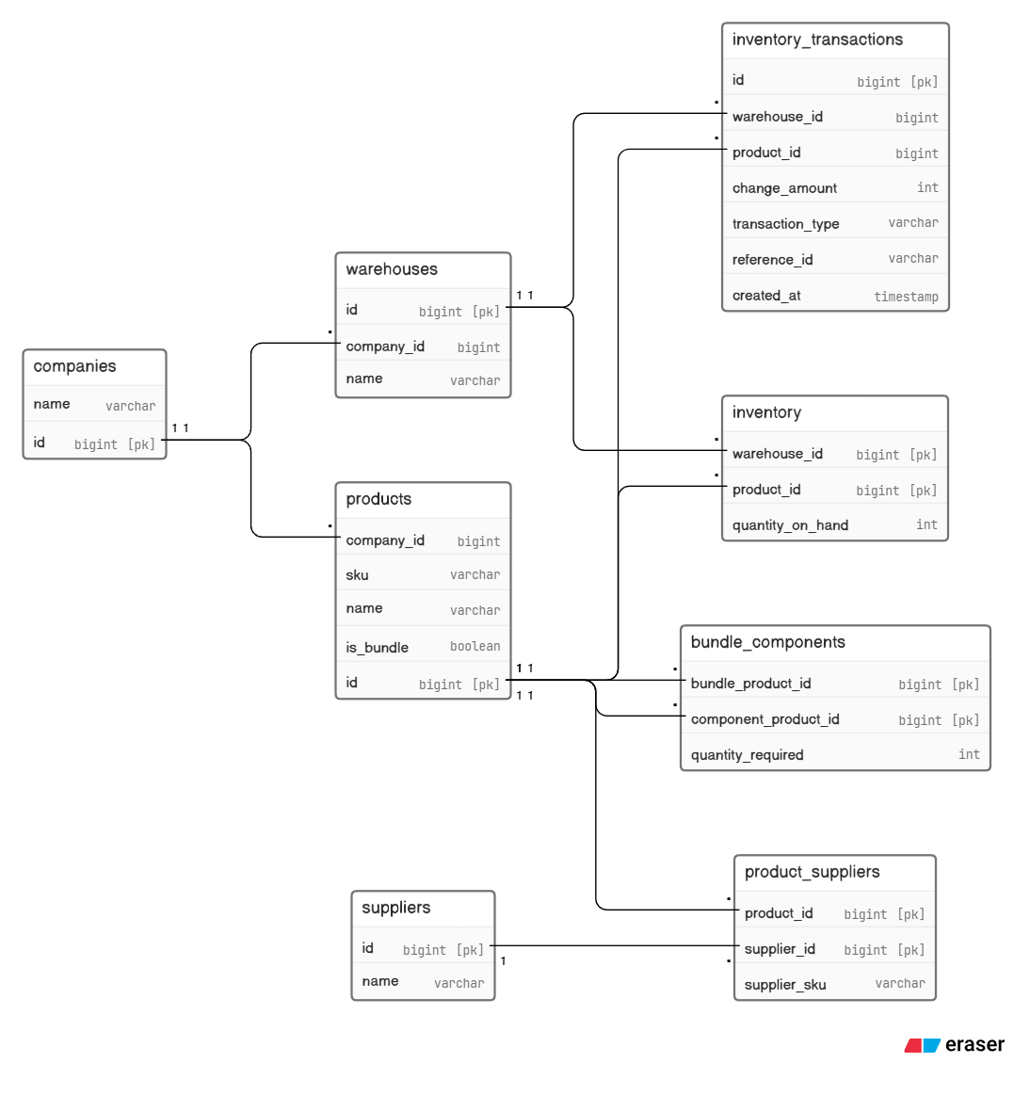

Made the Entity - relationship diagram on eraser.io, here is the link to view – https://app.eraser.io/workspace/0wKqBadhhZuIhveQgAyQ?origin=share

Questions ->
Are suppliers global entities or per-company? Can the same physical supplier appear as two separate suppliers rows for two different companies?
Is quantity_on_hand always non-negative, or can it go negative (backorders)? Should there be a reserved_quantity or available_quantity derived field? Is there a reorder point or safety stock concept needed?

Decisions ->
Indexes I'd add ->
products(company_id, sku) for SKU lookups scoped to a company; inventory_transactions(warehouse_id, product_id, created_at DESC) for time-series queries; inventory_transactions(reference_id) if you frequently look up transactions by order ID.

inventory_transactions as an append-only log. The inventory table then acts as a materialized view of the running total fast reads, updated on every transaction.

Part 3: API Implementation

Endpoint Specification:
GET /api/companies/{company_id}/alerts/low-stock

Expected Response Format:
{
"alerts": [
{
"product_id": 123,
"product_name": "Widget A",
"sku": "WID-001",
"warehouse_id": 456,
"warehouse_name": "Main Warehouse",
"current_stock": 5,
"threshold": 20,
"days_until_stockout": 12,
"supplier": {
"id": 789,
"name": "Supplier Corp",
"contact_email": "orders@supplier.com"
}
}
],
"total_alerts": 1
}

Techstack -> Nodejs, TS, PostgreSQL, Prisma ORM, Express
One trade-off to flag if asked -> the threshold filter (quantity_on_hand >= threshold) happens in JS rather than the DB because Prisma can't do WHERE quantity < product.low_stock_threshold in a single findMany. For large datasets you'd drop back to prisma.$queryRaw for that predicate.
Code -> lowstock.controller.ts

import express, { Request, Response } from "express";
import { prisma } from "./db"; // assumed

const router = express.Router();

const SALES_WINDOW_DAYS = 30;
const DEFAULT_THRESHOLD = 10;

router.get("/api/companies/:company_id/alerts/low-stock", async (req: Request, res: Response) => {
const companyId = parseInt(req.params.company_id, 10);

if (isNaN(companyId)) return res.status(400).json({ error: "Invalid company_id" });

const since = new Date();
since.setDate(since.getDate() - SALES_WINDOW_DAYS);

try {
// get all inventory rows for this company
const inventory = await prisma.inventory.findMany({
where: {
warehouse: { company_id: companyId },
product: { company_id: companyId },

// only products with at least one outbound transaction in the window
product: {
company_id: companyId,
inventory_transactions: {
some: {
transaction_type: { in: ["sale", "transfer_out"] },
change_amount: { lt: 0 },
created_at: { gte: since },
},
},
},
},
include: {
warehouse: true,
product: {
include: {

// aggregate sales for burn rate
inventory_transactions: {
where: {
transaction_type: { in: ["sale", "transfer_out"] },
change_amount: { lt: 0 },
created_at: { gte: since },
},
select: { change_amount: true },
},
// primary supplier only
product_suppliers: {
orderBy: { supplier_id: "asc" },
take: 1,
include: { supplier: true },
},
},
},
},
});

const alerts = inventory
.map((row) => {
const threshold = row.product.low_stock_threshold ?? DEFAULT_THRESHOLD;

// skip if stock is not below threshold
if (row.quantity_on_hand >= threshold) return null;

const totalSold = row.product.inventory_transactions.reduce(
(sum, tx) => sum + Math.abs(tx.change_amount),
0
);
const dailyRate = totalSold / SALES_WINDOW_DAYS;
const primarySupplier = row.product.product_suppliers[0]?.supplier ?? null;

return {
product_id: row.product_id,
product_name: row.product.name,
sku: row.product.sku,
warehouse_id: row.warehouse_id,
warehouse_name: row.warehouse.name,
current_stock: row.quantity_on_hand,
threshold,
days_until_stockout: dailyRate > 0 ? Math.round(row.quantity_on_hand / dailyRate) : null,
supplier: primarySupplier
? { id: primarySupplier.id, name: primarySupplier.name, contact_email: primarySupplier.contact_email }
: null,
};
})
.filter(Boolean)
.sort((a, b) => a!.current_stock / a!.threshold - b!.current_stock / b!.threshold);

res.json({ alerts, total_alerts: alerts.length });
} catch (err) {
res.status(500).json({ error: "Internal server error" });
}
});

export default router;

